**PROJECT ABSTRACT**

**TITLE: SMART AGRICULTURE**

**DESCRIPTION:**

Agriculture is the major occupational sector in India. It plays a major role in the development of the country as the Indian roots lie in agriculture. Agriculture plays a crucial role in Indian economy.Indian agriculture sector accounts for 18 per cent of India's gross domestic product (GDP) and provides [employment](https://www.omicsonline.org/searchresult.php?keyword=employment) to 50% of the countries [workforce](https://www.omicsonline.org/searchresult.php?keyword=workforce). Indian is an agriculture-based country, where more than 50% of population depends on agriculture. This structures the main [source of income](https://www.omicsonline.org/searchresult.php?keyword=source%20of%20income). The commitment of agri-business in the national income in India is all the more, subsequently, it is said that agriculture in India is a backbone for Indian Economy.

**PROBLEM STATEMENT:**

Most of the time constant check of the moisture levels of the soil is not done due to which the crop production fails. It is widely recognised that environmental problems such as soil degradation (erosion and desertification) affects many agricultural lands globally. These problems have caused soil quality decline, crop yield reduction, economic crisis, poverty, unemployment, and rural urban migration. Soil management practices are considered as the most vital and sustainable possible solution to control soil erosion and desertification.

**SOLUTION:**

To overcome this constant monitoring of soil moisture levels is required**.**

**Soil moisture sensors** measure the volumetric [water content](https://en.wikipedia.org/wiki/Water_content) in [soil](https://en.wikipedia.org/wiki/Soil). Since the direct [gravimetric measurement](https://en.wikipedia.org/wiki/Gravimetric_analysis) of free soil moisture requires removing, drying, and weighting of a sample, soil moisture sensors measure the volumetric water content indirectly by using some other property of the soil, such as electrical resistance, dielectric constant, or interaction with [neutrons](https://en.wikipedia.org/wiki/Neutron), as a proxy for the moisture content

Measuring soil moisture is important for [agricultural](https://en.wikipedia.org/wiki/Agriculture) applications to help farmers manage their [irrigation systems](https://en.wikipedia.org/wiki/Irrigation_system) more efficiently. Knowing the exact soil moisture conditions on their fields, not only are farmers able to generally use less water to grow a crop, they are also able to increase yields and the quality of the crop by improved management of soil moisture during critical plant growth stages.

**ALGORITHM:**

**The above block diagram describes the basic working principle of the project.**

**BLOCK DIAGRAM:**

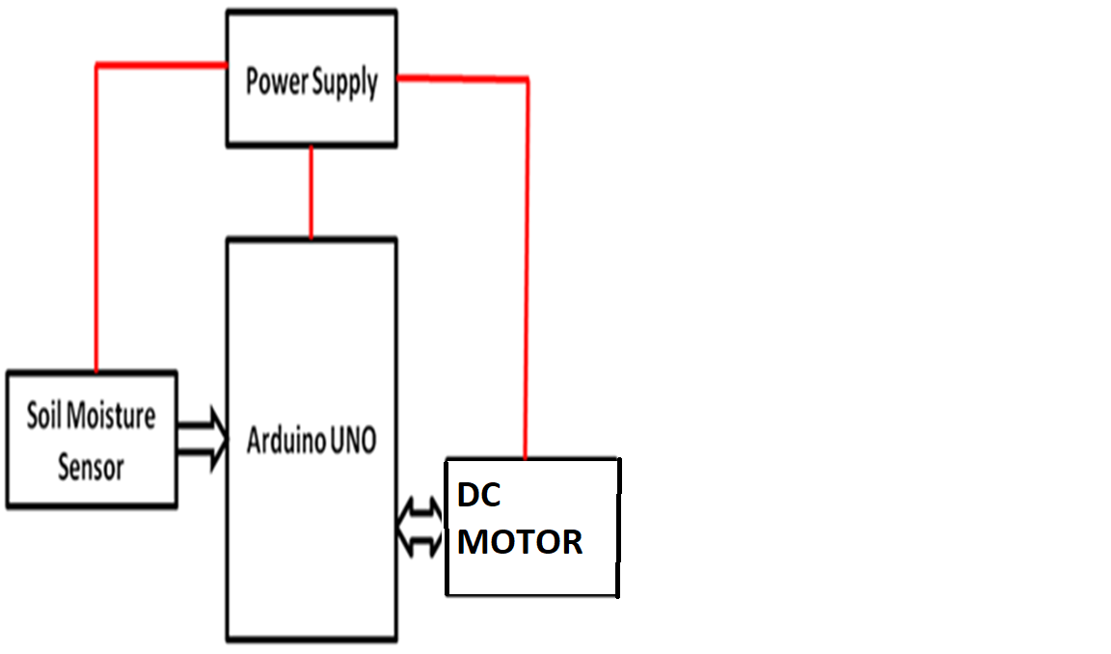

**REPRESENTATION:**

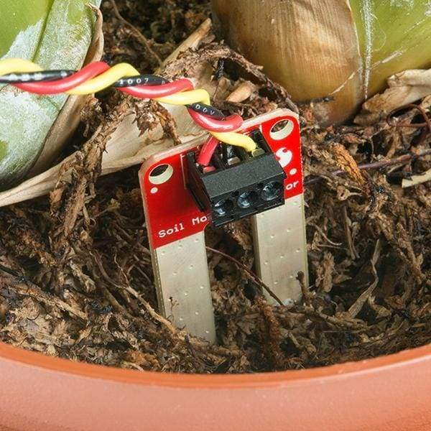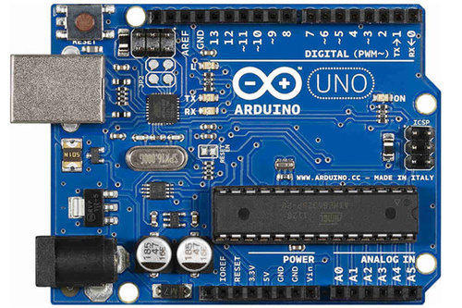

**DOCUMENTED BY:**

**K NAGA SRI NAVYA**

**Mail id:** [**kotanavya456@gmail.com**](mailto:kotanavya456@gmail.com)

**THANK YOU**